To create a session, go to your course and the topic area where you would like to have the session. Turn editing on, .

In the Settings Block have the Activity chooser off

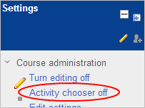

click on Add and activity or resource…

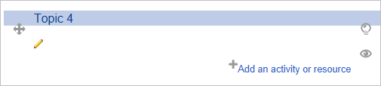

Select a resource such as for example a Page, from the drop down list, and click on Add

Click on the MediaCore logo
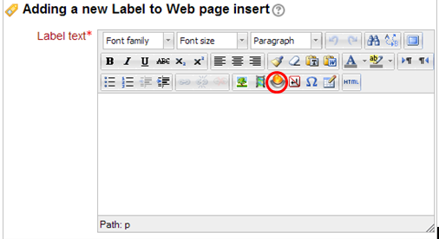

If you already have the video in your library, click on the Library tab on the left, and on Add to the right of the video you would like to add to your course.

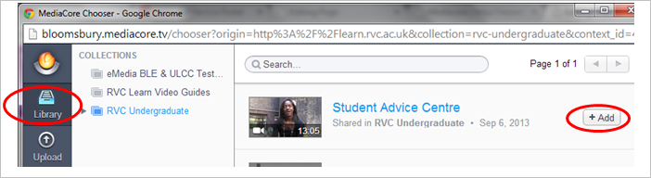

The video will now appear in your Moodle course:

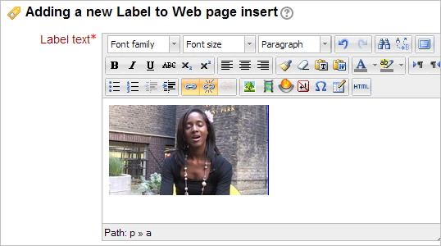

Enter text in the required fields -

And click on Save

--------------------------------------------------

If you have a video on your computer but that is not (yet) in your library, click on the Upload tab, and then on Choose a file

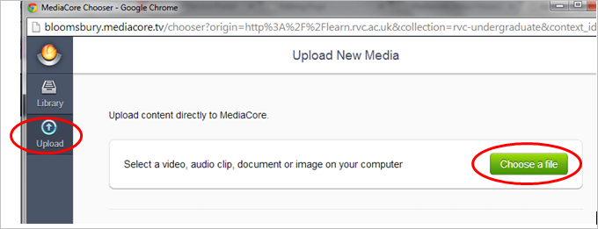

Add a Description and any Tags you would like, to help search for the video.

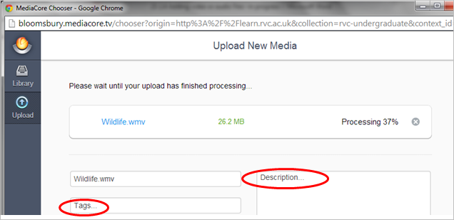

When the file has successfully uploaded , click on Publish .

The video will now be in your library.

Again follow the instructions above to Add the video to your Moodle course page.

--------------------------------------------------
The video you have added to your course page, will be embedded and ready to play in your course.

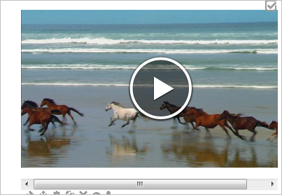

Please also refer to the MediaCore support website for further guides-

http://support.mediacore.com/customer/portal/articles/

Getting Help

Birkbeck: moodle@bbk.ac.uk
IOE: vle@ioe.ac.uk
LSHTM: elearning@lshtm.ac.uk
RVC: learn@rvc.ac.uk
SOAS: ble@soas.ac.uk

