Turnitin – Paper not submitting and FAQs
This document is designed to help students when they are having problems submitting their assignments through Turnitin on RVC Learn.
There are several steps that can be taken when having problems with Turnitin submissions.
1. Connection to the Internet / RVC Learn
All Turnitin submissions are processed online, and so an internet connection is essential to be able to submit your assignments.
RVC Learn must be used to access the appropriate Turnitin assignment. You must login to RVC Learn with your own username and password. Please do NOT login with anyone else’s details – your assignment may get over-written and lost!
All Turnitin submission links within RVC Learn look like:
2. File Types
All files submitted to Turnitin must be text based. Turnitin currently accepts the following file types:
- MS Word (.doc or .docx)
- WordPerfect (.wpd)
- PostScript (.eps)
- Portable Document Format (.pdf)
- HTML (.htm)
- Rich Text (.rtf) and Plain Text (.txt).
Files that are password protected, encrypted, hidden, system files, or read only files cannot be uploaded or submitted to Turnitin.
Please ensure that any document is not blank or have less than 20 words – Turnitin will not accept the submission.
Documents containing only images or scanned pdfs will also not submit correctly through Turnitin.
3. File Size
There is a limit of 20 megabytes (MB) on the size of the file you can upload to Turnitin. Most text based documents will not be larger than 20 MB, but if they are it's normally due to the inclusion of large graphics.
If you would like to learn how to reduce the sizes of your graphics, please refer to the guide on how to reduce image sizes in word documents in appendix A.
4. Submission Time
Submitting your work online a few minutes before the deadline is risky. It can take a few minutes for the system to 'register' your submission and it will 'stamp' your work late if this happens even a few seconds after the deadline. If you want to be safe and also check your work you need to submit at least 24 hours before the deadline.
5. Use the Text based submission process
Turnitin has been setup so that students can copy and paste their assignments into a submission box, which is then uploaded to Turnitin. This method is used instead of uploading a document.
Although this method will remove pictures, graphs and charts, these are not actually checked for plagiarism, so it has no effect on your originality score.

- Click on My Submissions within the Turnitin assignment.
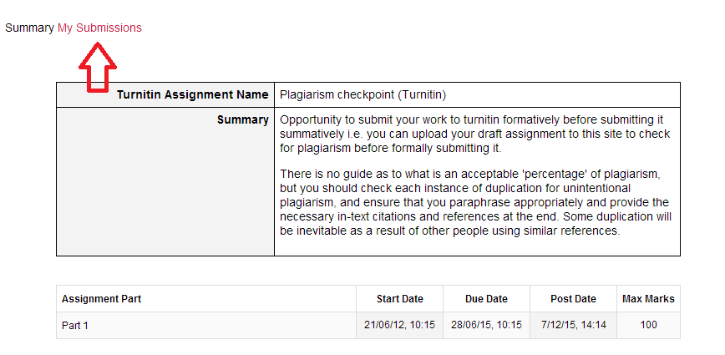

- Under Add Submission, drop down the submission type, and select Text submission.
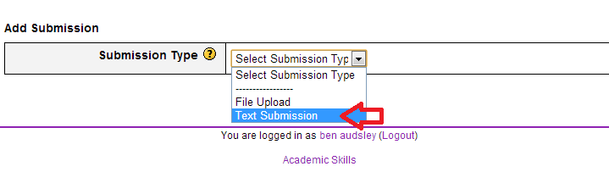
- Title the submission.
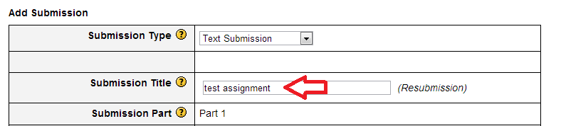

- Copy your whole assignment, and paste it into the “Text to Submit” box.

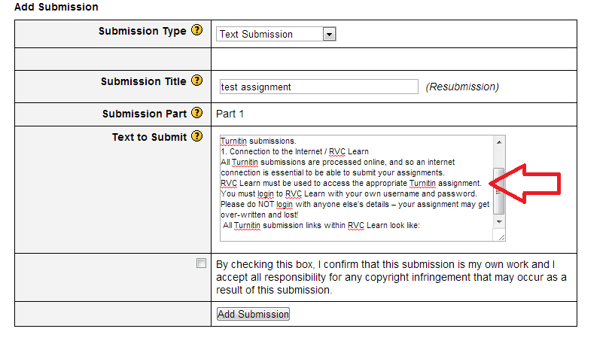
- Click on Add Submission to upload your assignment to Turnitin.

6. Email your submission to the RVC Learn Team
If you are still having problems with uploading your assignment to Turnitin, and you have tried every other step detailed in this document, then the final, last resort step is to email your assignment to learn@rvc.ac.uk , CLEARLY stating:
- Your name
- Your assignment title
- The course you are submitting your assignment
- The steps you have taken so far to try to upload the assignment to Turnitin
- Any screenshots or examples of any problems you may have encountered

FAQs
I've submitted my work, why does it say 'Pending' ?
This means your work is waiting to be checked by Turnitin. It does not mean your work is waiting to be submitted. Your work is in but not checked yet.
I've submitted my work, but it still says 'Pending' – how long will it take?
The first time you submit a piece of work, it can take between a few seconds and a few hours to return your report, but it may take significantly longer at peak hand-in times.
I've just submitted my assignment, but the report isn't showing yet. How long does it take?
In busy periods, it can take up to 24 hours.
I've submitted my assignment, and am still waiting for the originality report – its been over 24 hours!
Please contact learn@rvc.ac.uk and explain that you have been waiting over 24 hours for the originality report.
I've submitted my work, why does it say 'Submit to Turnitin’ ?
The paper is unprocessed by Turnitin as they are blank, contain only images or are scanned pdfs, or else are corrupted files or files with less than 20 words.

What happens if I've uploaded the wrong work or to the wrong place?
You need to resubmit the correct bit of work to the correct assignment. You also need to warn your lecturer that you have submitted the same work elsewhere as he/she will see the match in the report.
Where is my email receipt?
An email receipt is sent to your rvc.ac.uk email account each time you submit. If you have setup email forwarding there is good chance that the email receipt is seen by the receiving account as spam and is removed to the junk mail box.
Where can I get further help and support?
The RVC Learn Team is dedicated to helping students with any problems they experience with RVC Learn.
The team has two offices, one in Camden and the other in Hawkshead. Please feel free to come and see us if you are having any problems with Turnitin.
F17 Camden
G73 Hawkshead
Please contact learn@rvc.ac.uk for all Turnitin related enquires. The RVC Learn mailbox is monitored throughout the day, and special priority will be given to Turnitin related issues around a key submission dates.
Appendix A – How to reduce image sizes in Microsoft Word
The file size of your assignment should be no more than 20MB when you upload your written assignment. Turnitin will not accept an assignment that is larger than 20Mb (MB stands for MegaBytes) and you will get an error message which looks like this:
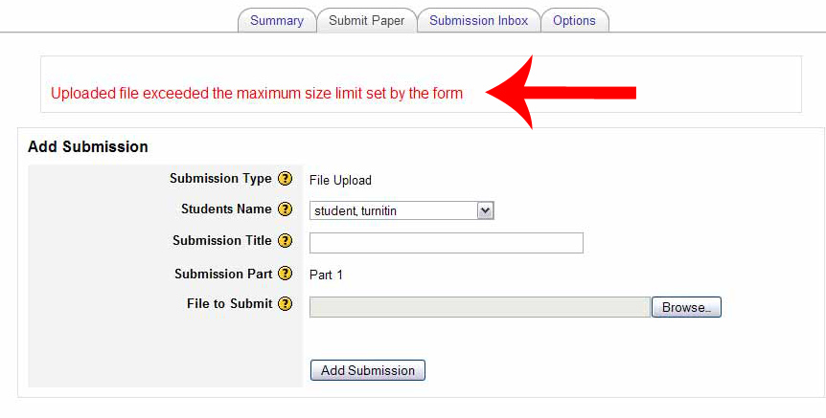
If your file size is too big it may be that your assignment contains uncompressed or un-optimised images or charts.
How to check your file size:
- On a PC, right click on the file and select properties.
- look for the file size in the window that appears. This window may look slightly different depending on what version of Windows you have.
- In the example below, the file size is 10.9Kb. KB stands for KiloBytes.

Example:
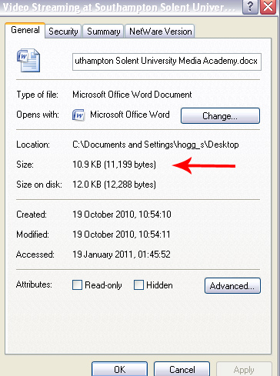

Microsoft Word 2007
Right click on any image in your document and select Format Picture...
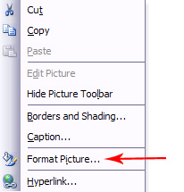
In the dialog box that opens click the Compress... button:
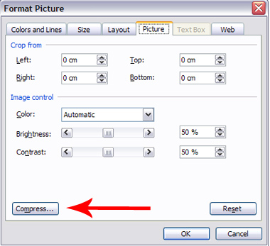
Make sure the All pictures in document option is selected and that the Compress pictures check box is ticked. Press OK:
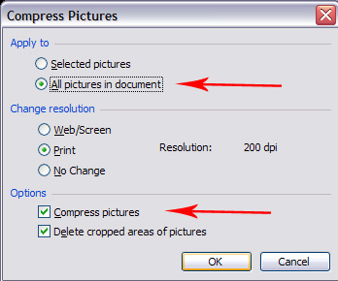
A dialogue box comes up asking if you want to Apply the changes. Click Apply:
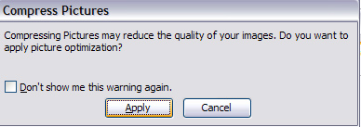
Microsoft Word 2010
Select any picture within your document.
Select the Picture Tools Format tab.
Click Compress Pictures.
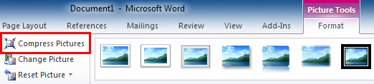
For .docx files this dialog box will appear:
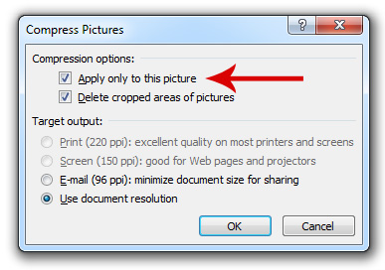
Deselect the Apply only to this picture option if you wish all pictures to be compressed.
Choose either the selected Use document resolution or the E-mail option to reduce the size of the images.
Compressing images before you add them to your document
- Keep your image file size to around 100KB.
- Avoid compressing your images too much as the image quality will be poor.
- Check the file size of the image you want to put into your assignment document before you add it, right click on the image file and select properties.

(provided by Ben Audsley –RVC)

